PCET’s & NMVPM’s

Nutan College of Engineering & Research (NCER)

(Affiliated to Dr. Babasaheb Ambedkar Technological University, Lonere)

CAD/CAM Assignment No: 01, 02, 03 on

**Modelling, Assembly and Drafting of Machine Parts Element using CATIA V5 (CAD Software)**

By

Mr. Chaudhry Sufiyan Ahmad Imtiyaz Ahmad

( PRN: 50641920181162511002 )

Guided By

Prof. P.V Mohite

|  |
| --- |
|  |

Department of Mechanical Engineering

NCER, Talegaon Dabhade

(2021-2022)

**Assignment No: 01, 02, and 03**

**Assignment Statement: Modelling, Assembly and Drafting of Machine Parts Element using CATIA V5 (CAD Software)**

**Press Tool** is a custom-built tool use to produce component majorly from sheet metal.

It is a combination of die, punch and some other accessories (like top plate, bottom plate, thrust plate guiding elements etc.) which are used to produce components from sheet metal with the application of pressure.

Press Tools are commonly used in mechanical, pneumatic & Hydraulic presses to produce sheet metal components at large scale.

Press Tools are classified into two types:

* **Open Tool:** -      In these types of tools, no die set are used. These types of tools are less accurate and lower in cost.
* **Close Tool:** -    Here die sets are used. These tools are more accurate and higher in cost.

In this Project, you will create all components of the Press Tool assembly, as shown in Figure 1, and then assemble them. The dimensions of the components are given in Figures 2 and 3 respectively.

Main Component of Press Tool

1.Top Plate

2.Guiding Elements (Guiding Piler)

3.Bottom Plate

Lets perform our Practical:

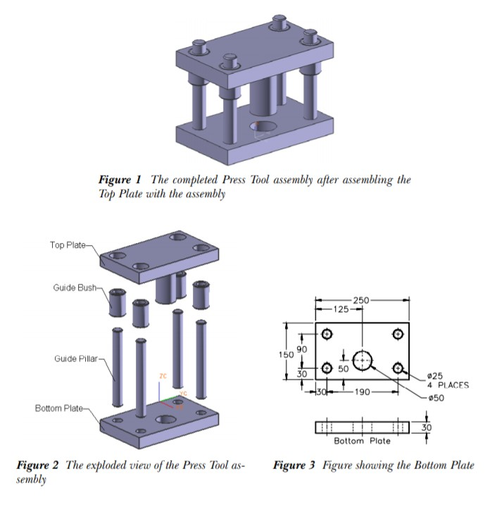

Figure 1: Press Tool Assembly



Figure 2: View and Dimensions of Top Plate

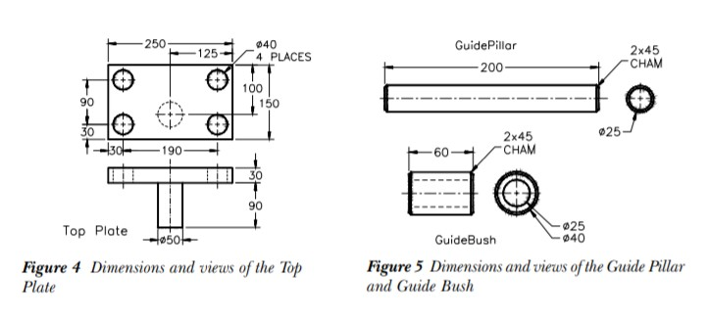

Figure 3: View and Dimensions of the Base Part and Rod Parts

1. **Bottom Plate:**

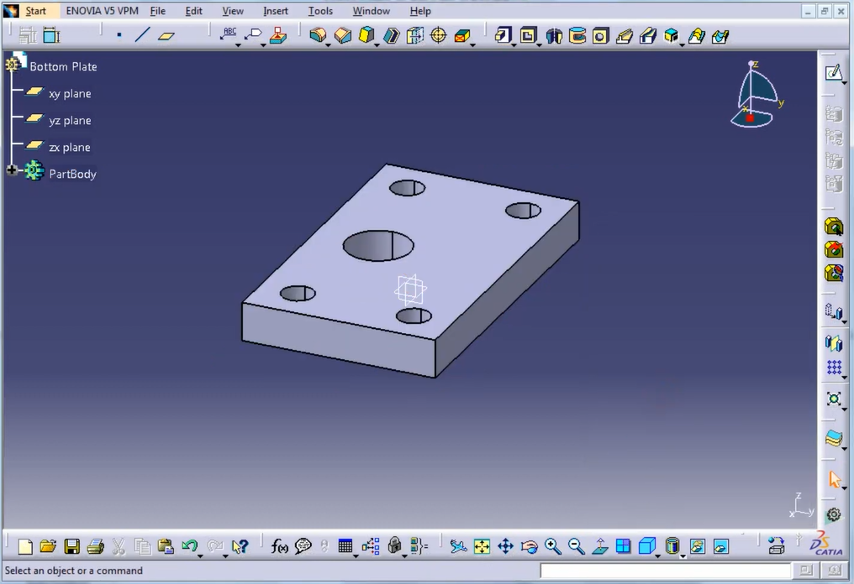

Fig: Bottom Plate

**Dimension:**



Fig: Dimension of bottom plate

**Methodology:**

Go to XY Plane then Sketcher Section select a center Rectangle.

Draw the Rectangle with any dimension then give dimension according to you with the help of constrain tool.

1.Draw a rectangle part of Dimension as follows:

Length = 150mm

Breadth = 250mm

To draw a circle , go to circle draw a circle with radius 50mm from down side of center of rectangle and 25mm above to base line.

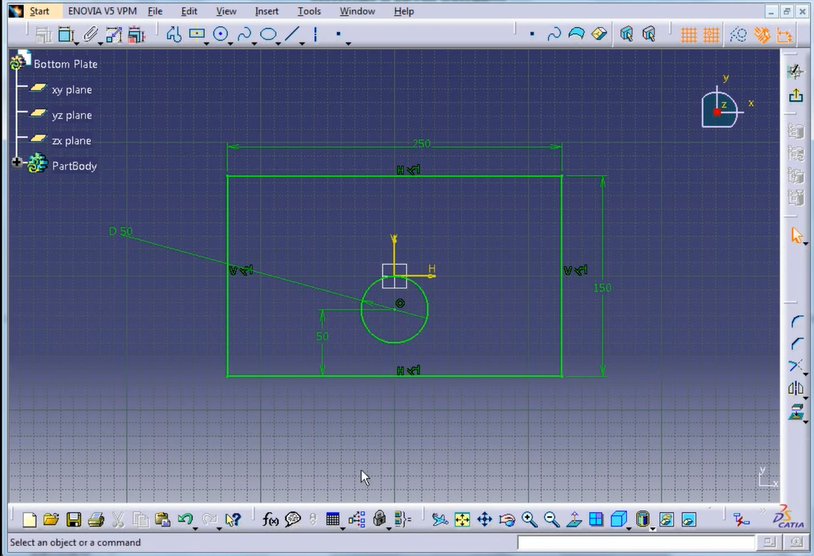

Then draw a circle again to make hole for guiding piler at right corner side of rectangle by using circle tool.

Radius of Circle is 20mm

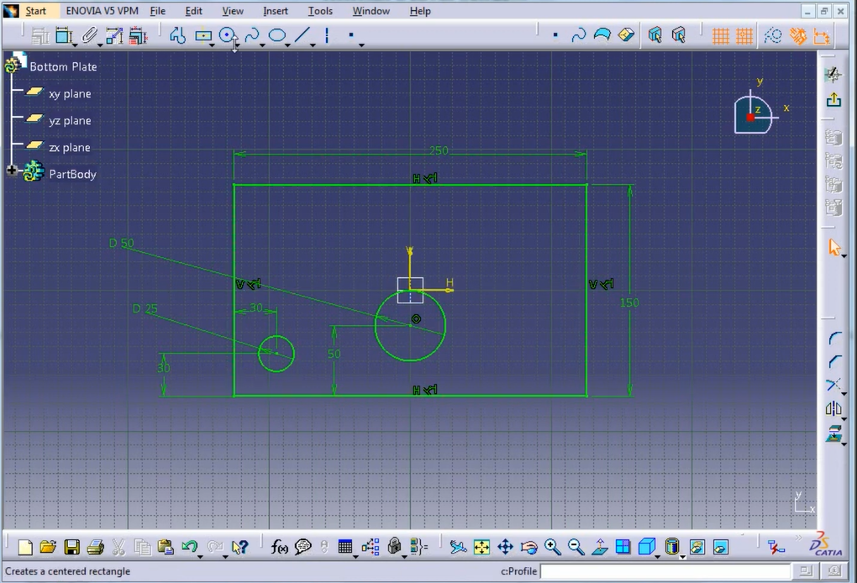

Select the imagenary line horizontally and verticle then

Go to mirror tool Then make a symetry to replicate the circle at left side as well as upper side

Then our Design Look like this

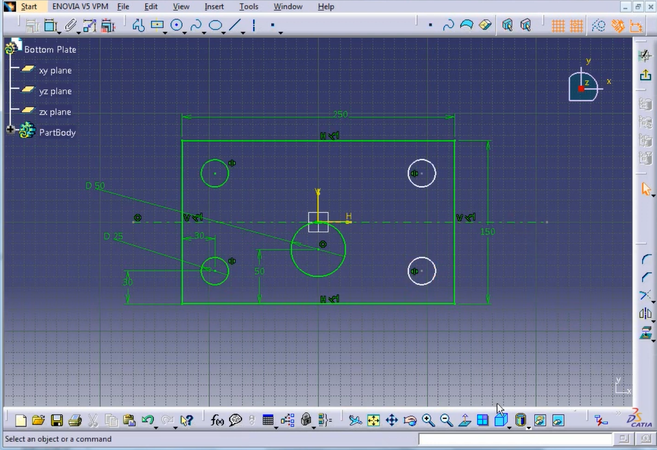

Convert 2D Drawing into 3D:

we will exit the Work one bench and go to pad section and we will put pad length here

Pad length = 30mm

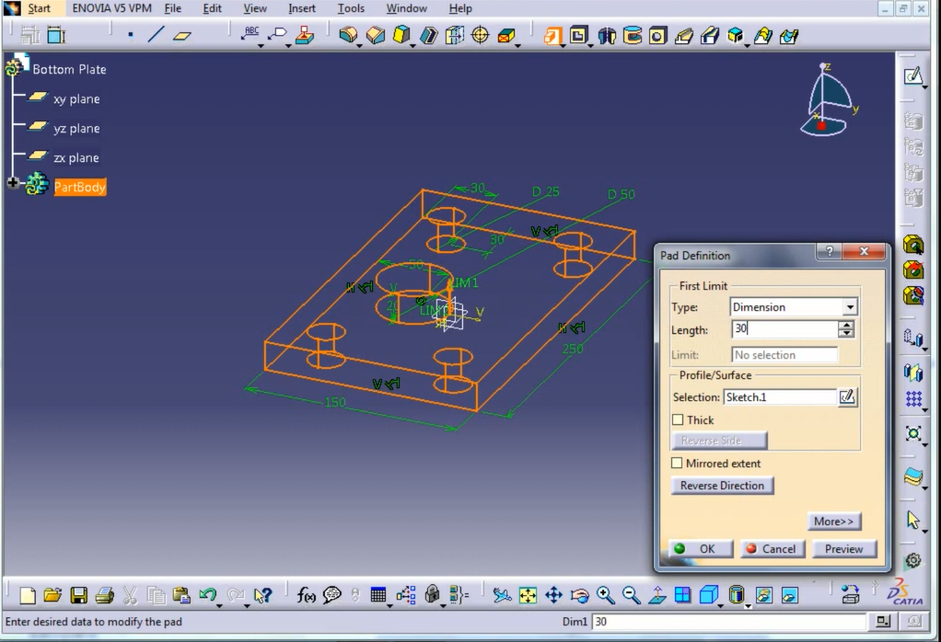

Now Our Bottom Plate is Ready



Fig: Bottom Plate

To draw another part, go to

Start 🡪 Mechanical Design Section 🡪 Part Design 🡪 Put part name

🡪 Click on OK

**2.TOP PLATE**

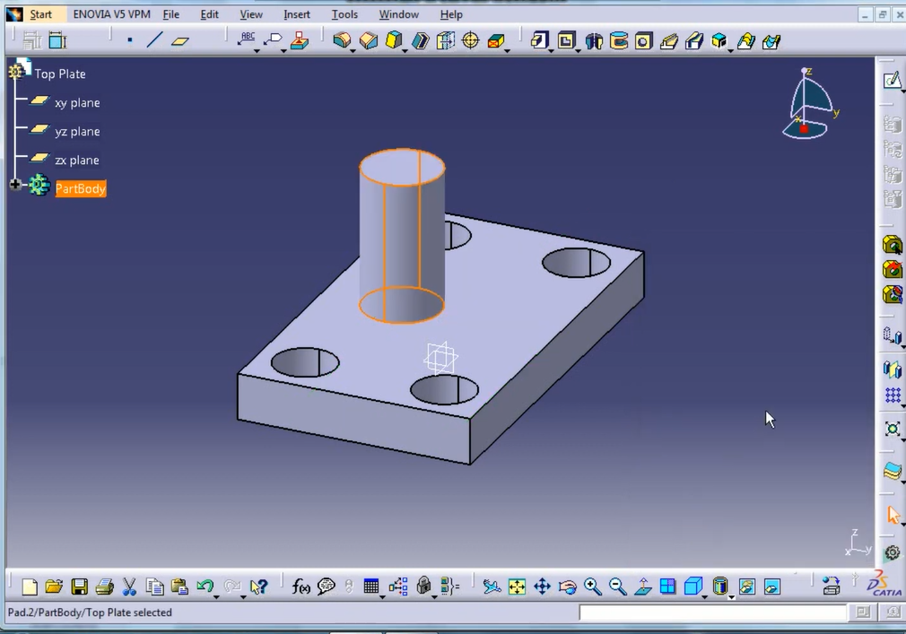

Fig: Top Plate

**Dimensons:**



Fig: Dimension of Top Plate

Select XY Plane Go to Skecher section

Draw the Rectangle with any dimension then give dimension according to you with the help of constrain tool.

1.Draw a rectangle part of Dimension as follows:

Length = 150mm

Breadth = 250mm

We have to draw four circles at following diameter:

Diameter = 40mm

Draw an any dimension circle at bottom left corner go to constrain tool give dimension 20mm radius above height from base line and left side 30mm respectively.

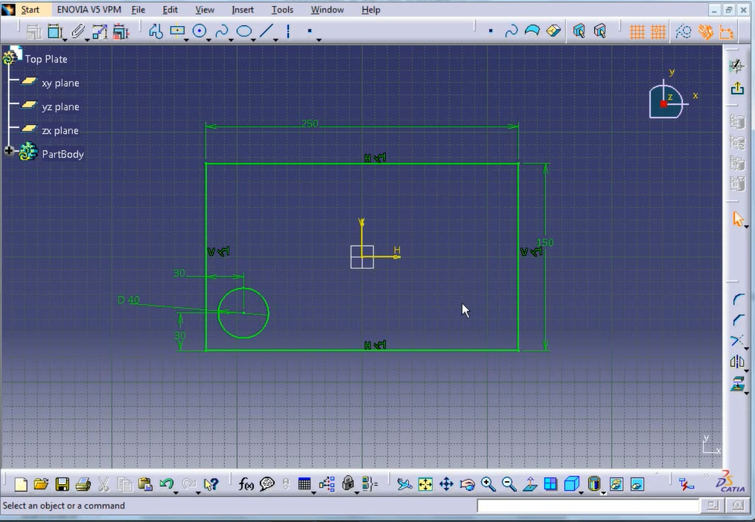

Select the imagenary line horizontally and verticle then

Go to mirror tool Then make a symetry to replicate the circle at left side as well as upper side

Then our Design Look like this

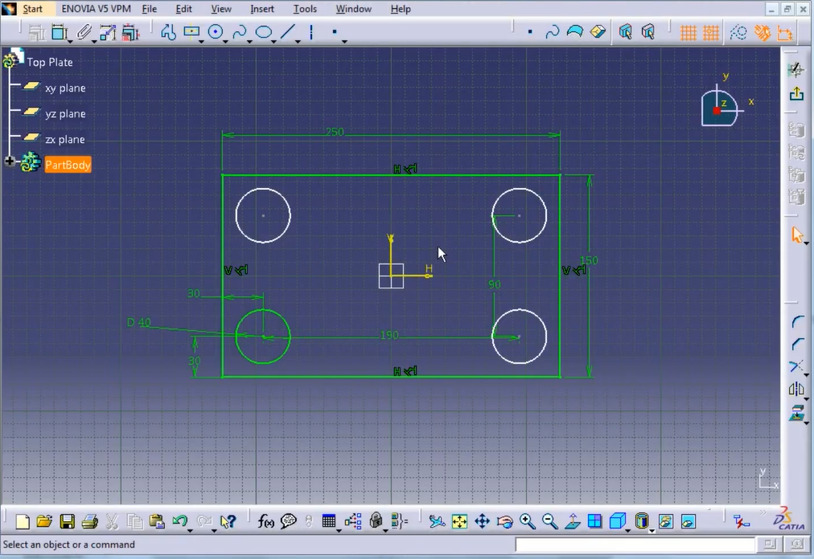

Convert 2D Drawing into 3D:

we will exit the Work one bench and go to pad section and we will put pad length here

Pad length = 30mm

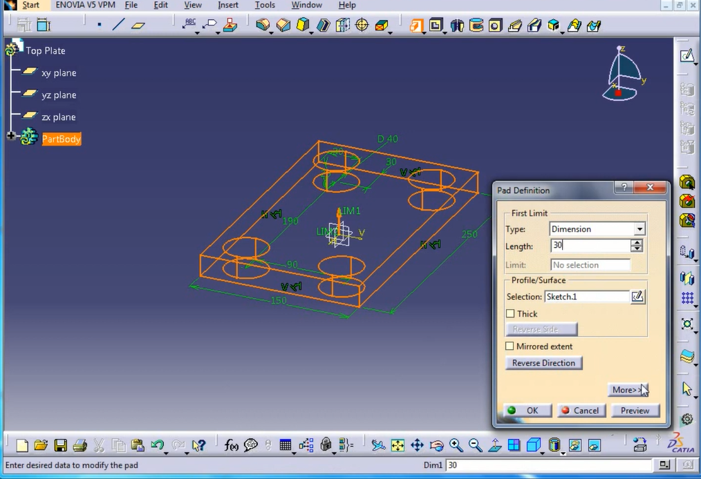

Now Our Top Plate is look like this

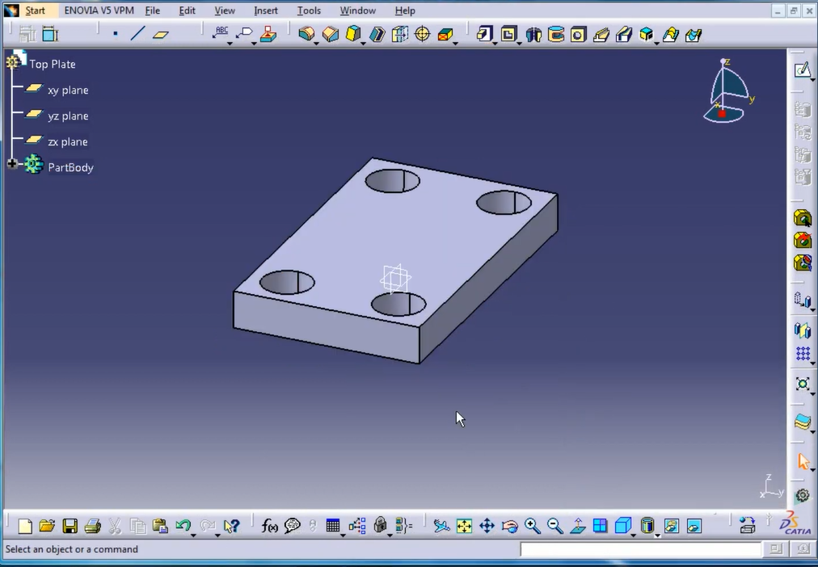

Fig: Top Plate

We Have to now make pad up 50mm circle and give pad length

go to pad section and we will put pad length here

Pad length = 90mm

Draw a circle below from centre of rectangle at 25mm

Give circle dimension 50mm by using circle tool.

we will exit the Work one bench and go to pad section and we will put pad length for this circle here

Pad length = 90mm

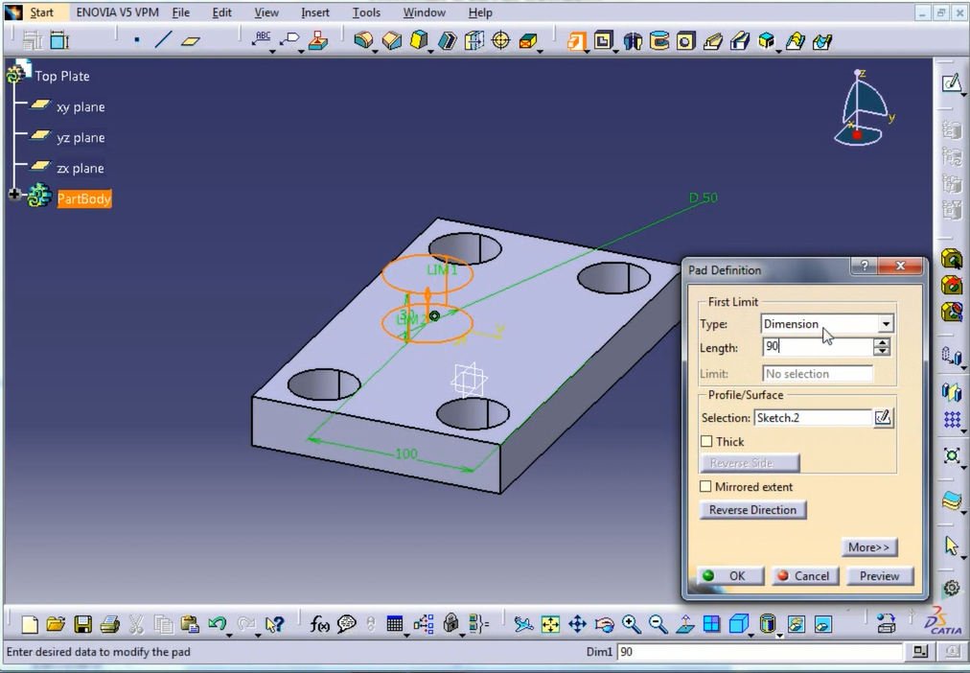

Press ok

Now our Top plate is ready.



To draw another part, go to

Start 🡪 Mechanical Design Section 🡪 Part Design 🡪 Put part name

🡪 Click on OK

**3.Guide Pillar**

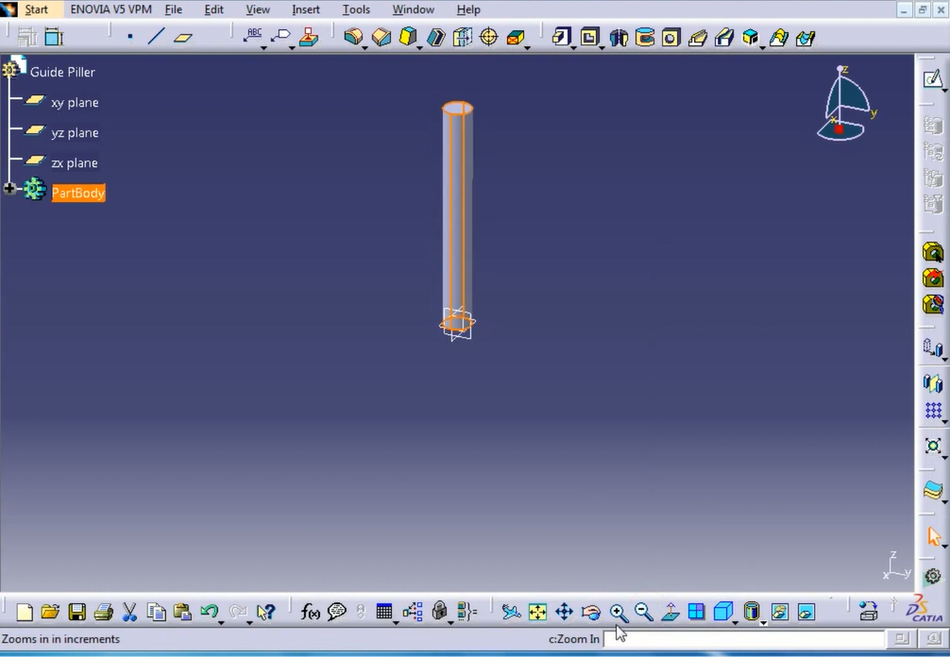

Fig: Guide pillar

**Dimensions:**



Fig: Dimension of Guide Pillar

Select XY Plane Go to Skecher section

Draw a circle at dimension 25mm

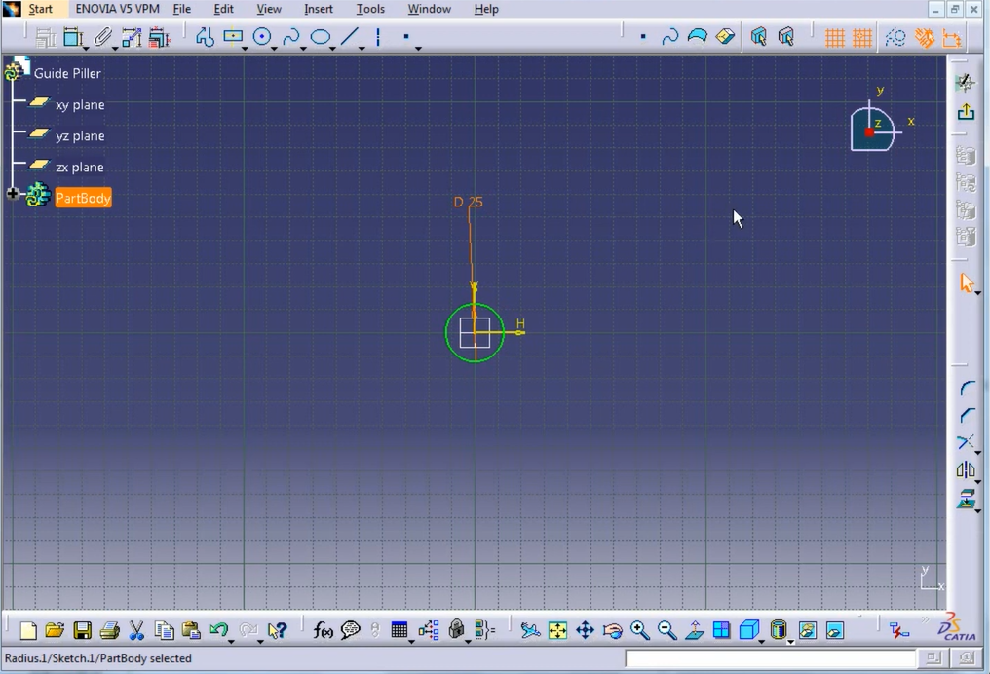

Convert 2D Drawing into 3D:

we will exit the Work one bench and go to pad section and we will put pad length here

Pad length = 200mm

Now our guide pillar is ready but something is missing.

Answer : Chamfering



Now we have to chamfer it from both side

Follow the same procedure on both the end of guid pillar to make chamfer.

Select the surface 🡪 go to chamfer tool 🡪give chamfer length & angle 🡪 press ok

Chamfer length = 2mm

Chamfer angle = 45 degree

After chamfer our guide pillar is ready

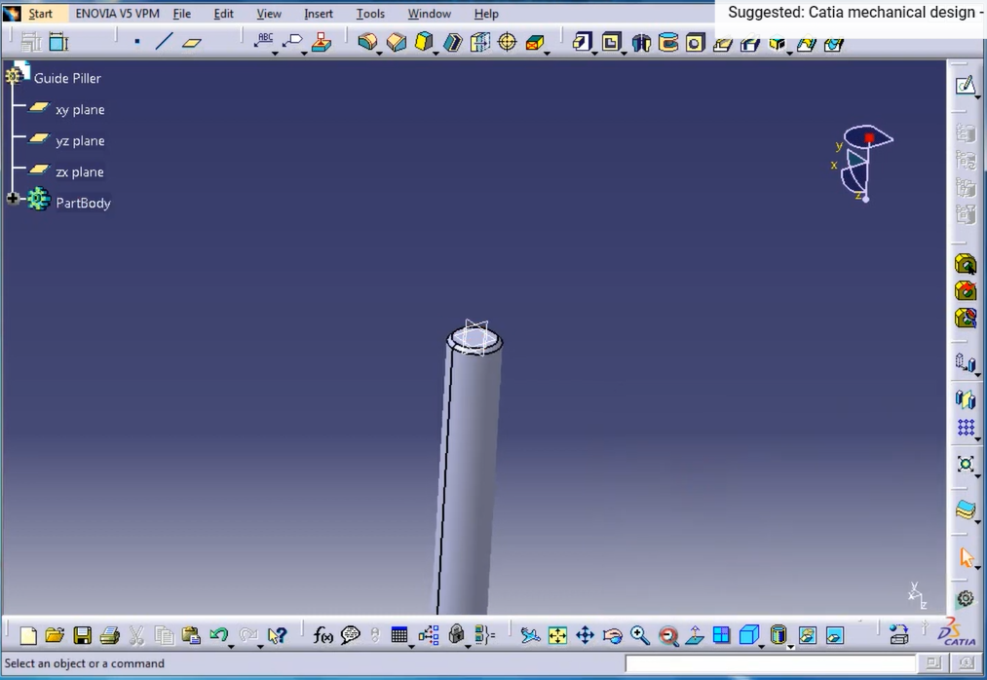

To draw another part, go to

Start 🡪 Mechanical Design Section 🡪 Part Design 🡪 Put part name

🡪 Click on OK

**4.GUIDE BUSH**

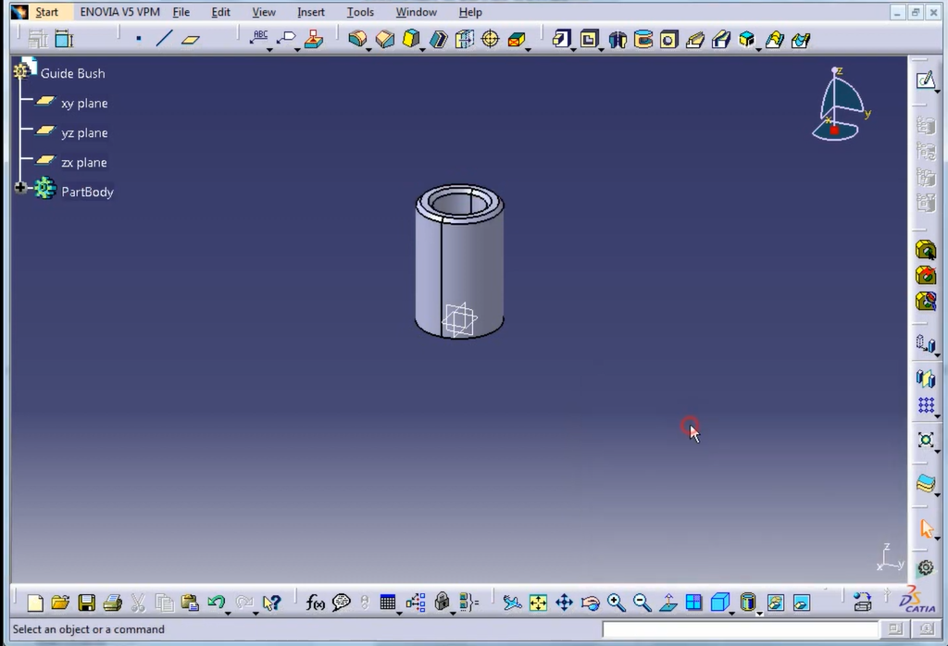

Fig: Guide Bush

**Dimension:**



Select XY Plane Go to Skecher section

Draw a circle at dimension 40mm and inside this again make a circle of dimension 25mm.

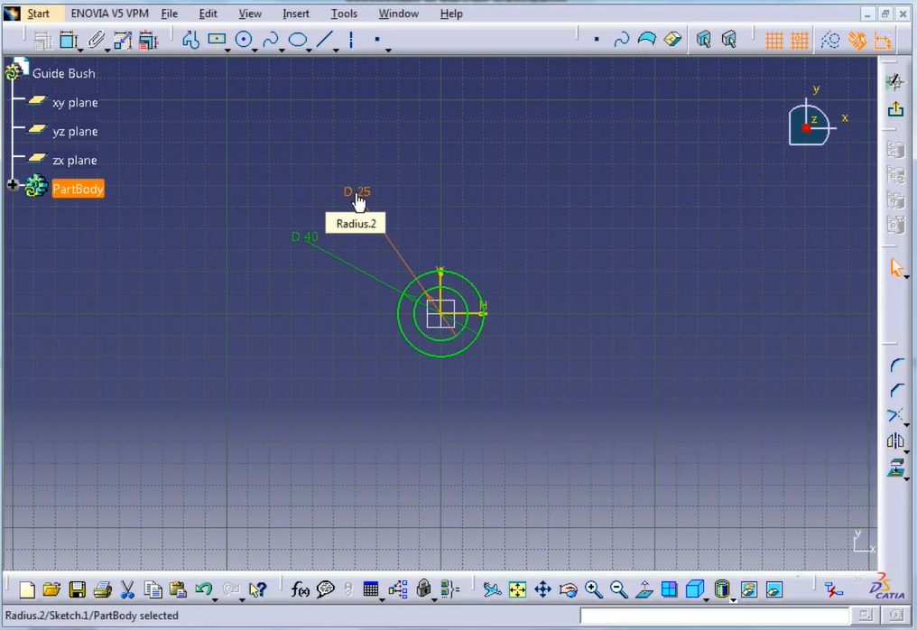

Convert 2D Drawing into 3D:

we will exit the Work one bench and go to pad section and we will put pad length here

Pad length = 60mm

Now our guide bush is ready but something is missing.

Answer : Chamfering

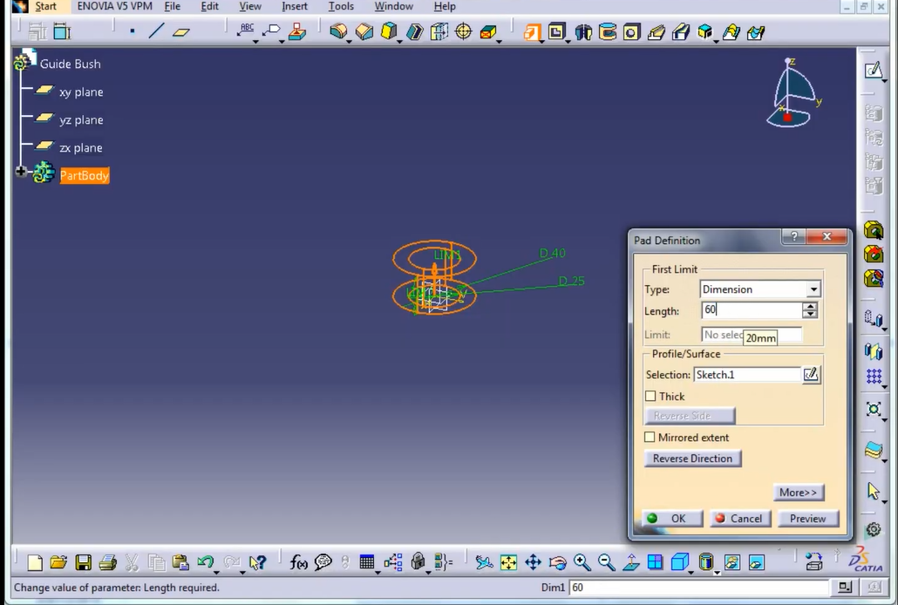

Now we have to chamfer it from both side

Follow the same procedure on both the end of guid pillar to make chamfer.

Select the surface 🡪 go to chamfer tool 🡪give chamfer length & angle 🡪 press ok

Chamfer length = 2mm

Chamfer angle = 45 degree

After chamfer our guide pillar is ready



Now we are ready with parts

Final Step:

We have to assemble all the parts to make our 3D model completely for that we used function namely “Assembly design”

Start -> Mechanical Design ->Assembly Design

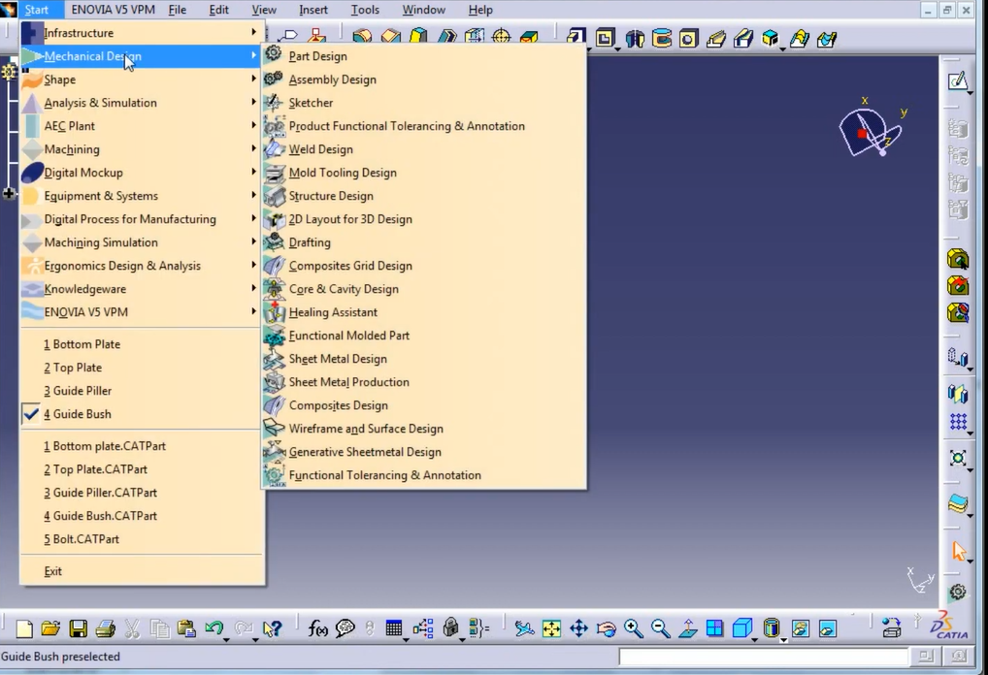

By selecting all the products, we have drown previously and press ok

And adjust with position

Here we have our Final result of Press Tool Model

